Lab 9- Advanced features of Iceberg

Estimated completion time
- 30 minutes

Learning objectives
- In this lab, you will explore Iceberg’s advanced features using an airplane dataset. Specifically, you will learn how tables can evolve in specific ways, including renaming columns, adding additional columns, renaming partitions, and eliminating partitions. At each step, you will see what impact these changes have on the records in the table and investigate how these changes are tracked by Iceberg using snapshot files.

Activities
- Prepare for the exercise
- Create table
- Insert records
- Change column name using ALTER TABLE
- Add new records
- Add additional columns using ALTER TABLE
- Modify existing records using new column layout
- Rename and partition table
- Add two new helicopters into modified table
- Check partition metadata
- Eliminate partitions
- Add new record to table after partitions eliminated
- Compaction

Step 1 - Prepare for the exercise
- Sign in and verify the students role is selected in the upper-right corner.
- Ensure the aws-us-east-1-free Cluster is reporting a Status of Running.
- In the Query editor, select aws-us-east-1-free in the cluster pulldown.

Note: If you did not previously create a schema, execute the following SQL statement. Make sure that you replace yourname with your actual name, or another identifier that you prefer. Only use lowercase characters and numbers; no special characters or spaces.

CREATE SCHEMA students.yourname;

Step 2 - Create table
In this lab, you will build and populate a table with airplane data.

Using the aws-us-east-1-free cluster, create an initial table layout in your schema with the following Data Definition Language (DDL).

USE students.yourname;

CREATE TABLE planes (
tail_number varchar(15),
name varchar(150),
color varchar(15)
) WITH ( type = 'iceberg');

Step 3 - Insert records
Insert two new records into the table using the code below.

INSERT INTO planes (tail_number, name)
VALUES
('N707JT', 'John Travolta''s Boeing 707'),
('N1KE', 'Nike corp jet');

Step 4 - Change column name using ALTER TABLE
At this point, you realize the name is really more of a description. Change the column name using the code below. Note the use of the ALTER TABLE syntax.

ALTER TABLE planes RENAME COLUMN name TO description;

Verify all is reporting correctly.

SELECT * FROM planes;

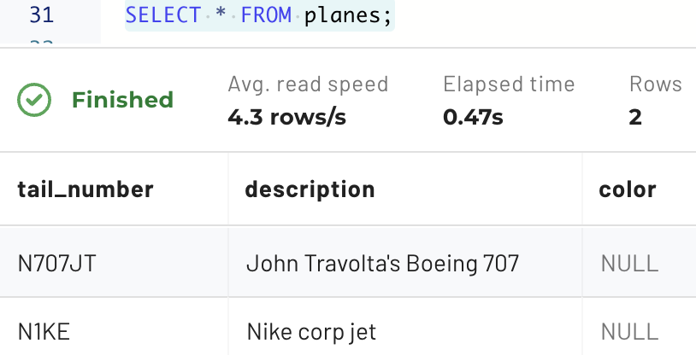

Step 5 - Add new records
Add another plane.

INSERT INTO planes (tail_number, color, description)
VALUES
('N89TC', 'white',
'1975 Bombardier Learjet 35 w/Light Jet classification');

Step 6 - Add additional columns using ALTER TABLE
At this point, you realize some additional columns are appropriate. Add them now using the code below.

ALTER TABLE planes ADD COLUMN class varchar(50);
ALTER TABLE planes ADD COLUMN year integer;
ALTER TABLE planes ADD COLUMN make varchar(100);
ALTER TABLE planes ADD COLUMN model varchar(100);

Additionally, the color column is not relevant enough to be maintained.

ALTER TABLE planes DROP COLUMN color;

Step 7 - Modify existing records using new column layout
Modify the existing three rows to leverage the new column layout.

UPDATE planes
SET class = 'Jet Airliner',
year = 1964,
make = 'Boeing',
model = '707-138B'
WHERE tail_number = 'N707JT';

UPDATE planes
SET class = 'Heavy Jet',
year = 2021,
make = 'Gulfstream',
model = 'G650'
WHERE tail_number = 'N1KE';

UPDATE planes
SET class = 'Light Jet',
year = 1975,
make = 'Bombardier',
model = 'Learjet 35',
description = null
WHERE tail_number = 'N89TC';

When complete, verify that the reporting is correct. The output should resemble the image below.

SELECT * FROM planes;

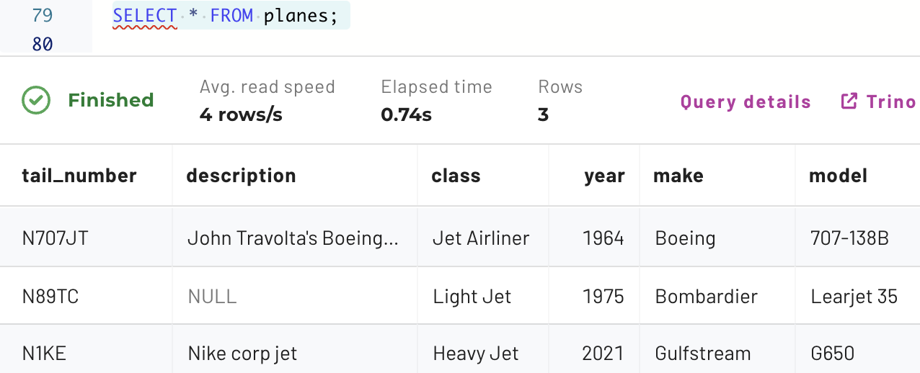

Step 8 - Rename and partition table
Imagine that your company has now decided to carry other types of aircraft, not just planes.

You can use ALTER TABLE to rename the planes table to allow for additional types, such as helicopters, to be added. The new name for the table will be aircrafts.

ALTER TABLE planes RENAME TO aircrafts;

Also, add partitioning on the classification column.

ALTER TABLE aircrafts
SET PROPERTIES partitioning = ARRAY['class'];

Step 9 - Add two new helicopters into modified table
Add two helicopters to the table as new records using the code below.

INSERT INTO aircrafts
(tail_number, class, year, make, model, description)
VALUES
('N535NA', 'Helicopter', 1969, 'Sikorsky', 'UH-19D', 'NASA'),
('N611TV', 'Helicopter', 2022, 'Robinson', 'R66', null);

When complete, verify that these records have been added using the code below.

SELECT tail_number, class, year, make, model, description
FROM aircrafts ORDER BY tail_number;

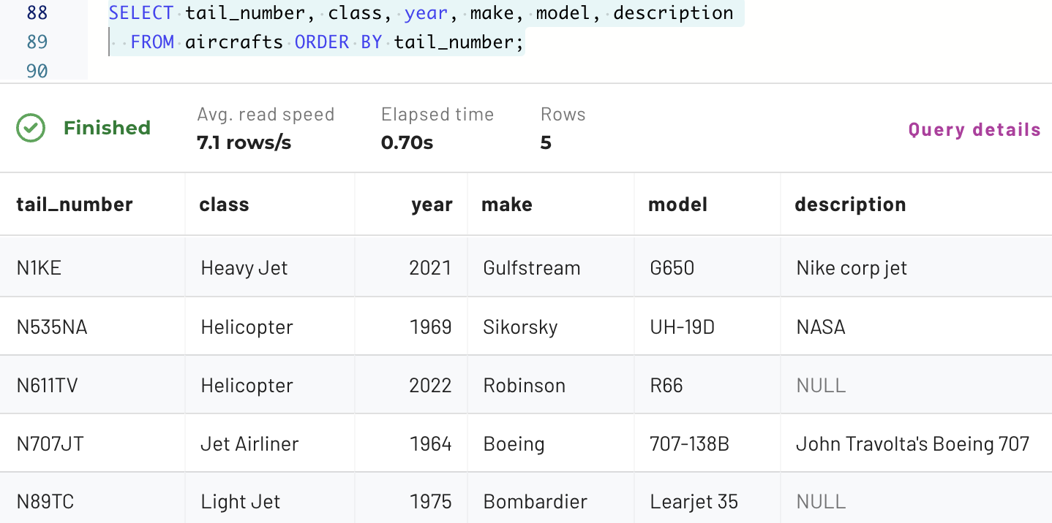

Step 10 - Check partition metadata
Check the $partitions metadata table to ensure that the metadata for the new records is being collected properly. There should be two records in the new partition. Use the code below.

SELECT partition, record_count, file_count
FROM "aircrafts$partitions";

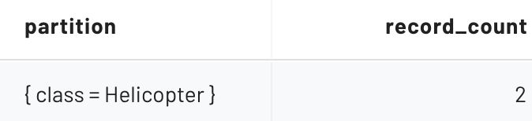

Step 11 - Eliminate partitions
Imagine that the needs of the business change. Fewer aircraft are being purchased than anticipated, and fewer are being added to the table as a result. Upon deeper analysis, you decide that partitioning is no longer necessary because the business need that gave rise to them is no longer true.

Eliminate the partitions using the ALTER TABLE command seen below.

ALTER TABLE aircrafts
SET PROPERTIES partitioning = ARRAY[];

Step 12 - Add new record to table after partitions eliminated
Add another helicopter record.

INSERT INTO aircrafts
(tail_number, class, year, make, model, description)
VALUES
('N911MU', 'Helicopter', 2012, 'MD Helicopters', '369E',
'St Louis County Police Dept');

Verify that 3 helicopters are present in the table.

SELECT tail_number, class, year, make, model, description
FROM aircrafts WHERE class = 'Helicopter';

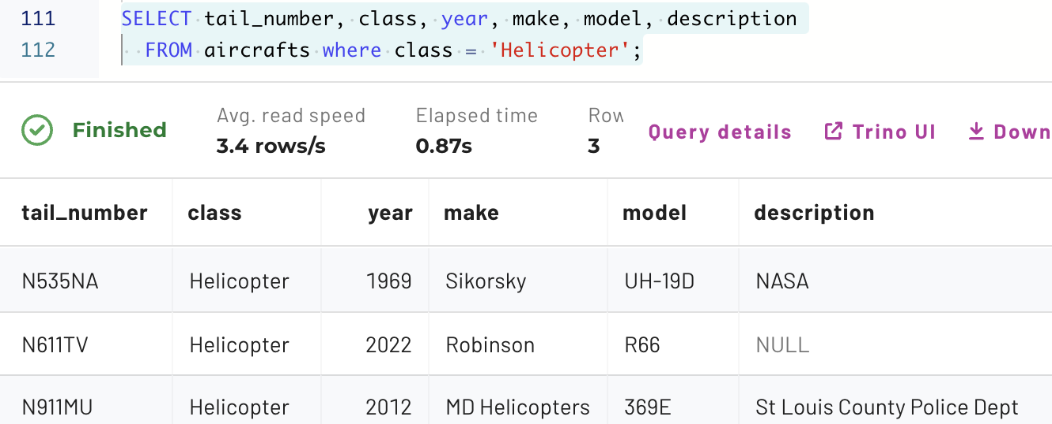

Look at the $partitions metatable again.

SELECT partition, record_count FROM "aircrafts$partitions";

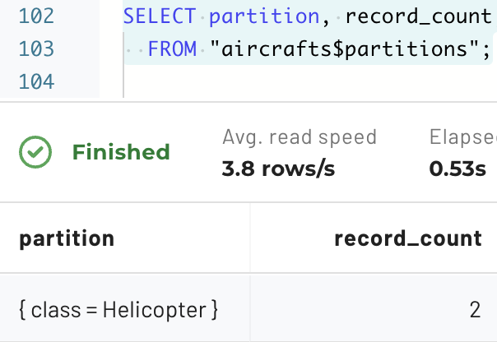

The new record has been successfully added without a partition, but the original two records remain inside the partition. This is an important point regarding the elimination of partition. Changes to partitions only impact new records but do not automatically alter old records created when the partition was in effect.

Step 13 - Compaction
Take a look at the $files metatable.

SELECT * FROM "aircrafts$files";

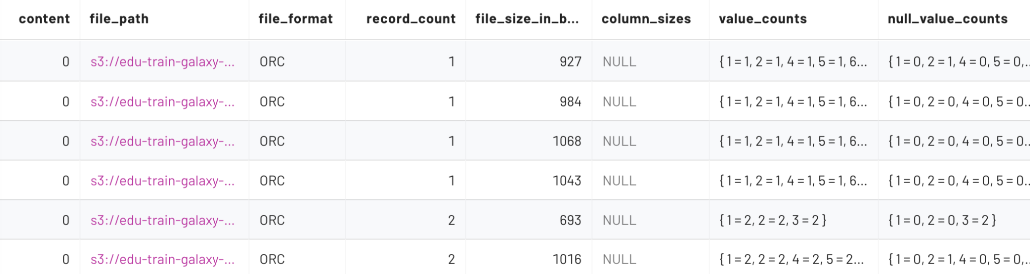

The output above shows a large number of small files. These files can be compacted together for better performance.

Run the following command. It will compact any file below a 10MB threshold.

ALTER TABLE aircrafts
EXECUTE optimize(file_size_threshold => '10MB');

Check the $files metatable again.

SELECT * FROM "aircrafts$files";

You will see there are fewer files present now using the query below.

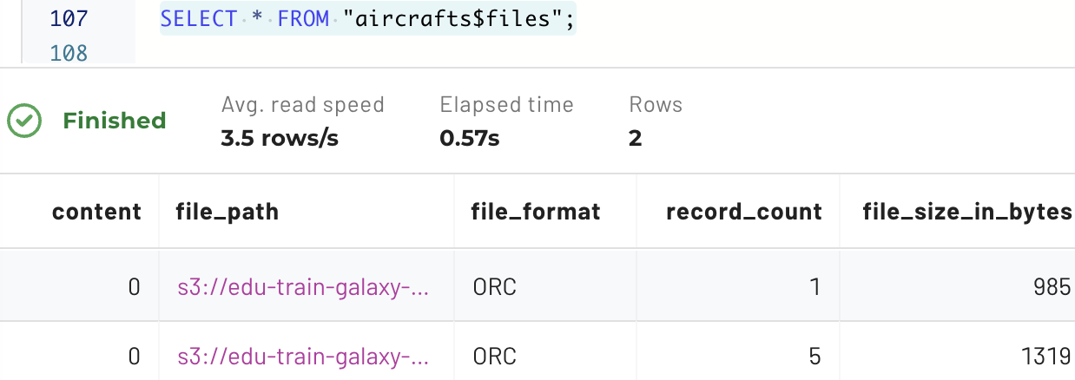

Note: These files are still very small in size due to the small number of records inserted into them. Nonetheless, the problem has been greatly reduced.

END OF LAB EXERCISE

